

Sri Lanka Institute of Information Technology

Evento 365 Event Management System

Project Proposal

Information Technology Project (IT2080) 2021

**KDY_2021_WD02**

Submitted by:

1. IT20205638 – U.M.D.B Alahakoon
2. IT20274252 – Y.G.I.S.Wickramanayake
3. IT20245092 – S.M.T.N. Samarakoon
4. IT20274320 – K.M.M.Y.S. Ranathunga
5. IT20224370 – D.M.C.L.B. Dissanayake
6. IT20133290 – R.M.Isuru Sahan Kumarasingha
7. IT20198336 – V.D.M.H.D. Rathnayake
8. IT20231682 – S.M.K.P.K. Sakalasooriya

Submitted to:

Ms. Sharmila Sivabalan

………………………….. (Supervisor’s signature)

31st of July 2021

Table of Contents

1 Introduction. 1

1.1 Problem Statement 1

1.2 Solution 1

2 Benefits of the System 2

3 System Overview 3

4 System Functions 4

4.1 User Account Management and Access Separation. 4

4.2 Booking\Location Management. 4

4.3 Catering Service Management. 4

4.4 Item Renting Service Management. 5

4.5 Vehicle Renting and Driver Management Service. 5

4.6 Evento 365 Store. 5

4.7 Payment Management. 6

4.8 Event Planning Agent Management. 6

5 Technologies Used 7

6 Gantt Chart 8

7 Task Distribution 9

8 References 13

# Introduction.

## Problem Statement

When we were seeking for a real-world problem, we found that people having really tough time when it comes to planning their events during the pandemic situation. Due to travelling restrictions people were unable to move directly to the places where event organizing related services offered, and also they failed to meet their expectation. Then we decided to develop a viable solution to the issue.

## Solution

Our system provides an event planning service via online; people can log into our system and use our facilities. Users can add their reservations according to their needs and we are committed to providing them with a valuable service. We accept various digital payment options to ease our customer payments. Our service is 24/7 available, so user can plan their events in an organized manner anytime anywhere with their fingertips.

# Benefits of the System

* Clients can book events anytime from anywhere and it saves time of the clients.
* An event planning system, it looks more professional and organized.
* Site Administration can manage stocks easily.
* Reservation process is much faster than an ordinary event reservation process.
* Useful reports which beneficial for the future of the service can be generated through the system.
* Evento 365 system provides a user-friendly interface to the customers.
* Payments can be done in a secured environment effectively.
* Evento 365 system costs so much less than a physical system.
* Customers can stay in touch more easily.

# System Overview

Following *Figure 1* shows system overview of the proposed Evento 365 system.

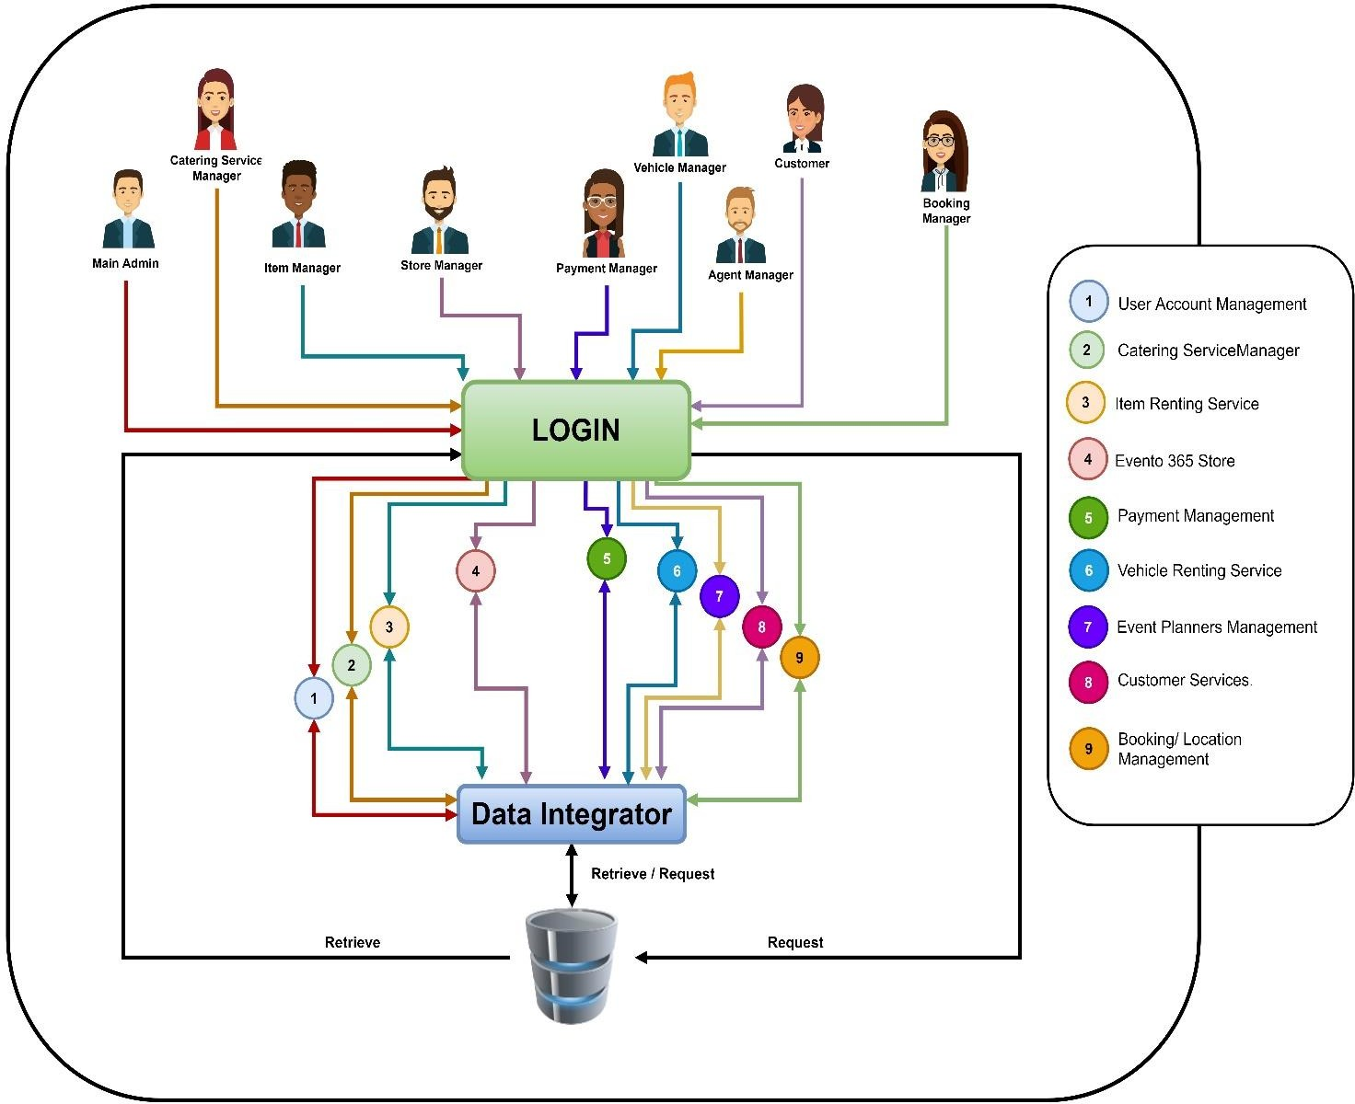

Figure 1 - System Overview Diagram

# System Functions

## User Account Management and Access Separation.

This service provides both Admins and Customers a secure registration and login environment. We added security measures to protect privacy of the user and only store the essential details in the system. The system provides password recovery facilities to the user. System also separates different types of admins to ensure the security of the website. Users are navigated to the relevant area of the site matching to their login details. Only the main admin capable of adding a new admin to the system.

## Booking\Location Management.

Evento 365 system provides customers to make their booking online. After inserting the customer's information into the system. Under the booking section user can select event locations, type of the event, no of guests, event date and other related information. The system displays a summary of booking details.

Using summary, customers can confirm or edit their booking details. Moreover, admins can review the booking and approve bookings. Also, admins can manage venues using the admin panel.

## Catering Service Management.

In this functionality only food administrator can manage all food items. The administrator responsible to adding new food items to the database, editing information and removing food items. At the end of the month food administrator generate the monthly report related to the food items and he can print this report. In this report display food details, monthly total income and the most booked food item. The system user can see our food items page, search and select desired food category and specifies the quantity he wants, the user can view the total price related to the selected food.

## Item Renting Service Management.

This part includes all the related details of items that are renting in Evento 365. Users can view all the details of the items and packages to get a clear idea before booking. They can select the quantities of items they want and complete their booking. Admin is responsible for add new items, edit the details, and delete the already added items. A report can be generated by admin to show the overview of monthly progress of rented items.

## Vehicle Renting and Driver Management Service.

Evento 365 system has tailored to fulfill your vehicle needs. Customers can select the best vehicle according to their requirements by browsing the vehicle catalog. The system displays available vehicles when the customer inputs the date. so, customer can ensure the vehicle is available on that date. After selecting the vehicle, the Customer can select a driver for the vehicle. Admin is responsible for modifying details about vehicles and drivers. And admin can generate monthly reports to show details such as most hired vehicles and least hired vehicles.

## Evento 365 Store.

Event 365 Store functionality manages the store which includes all the party/event-related items. Customers can search for any sort of item and manage a cart to add items, remove items and make changes to the number of each item in their cart. Customers can place an order by confirming the checkout order and then providing shipping and order related details. The appointed store admin is responsible for updating the current stock-based upon items purchased and he can add new products or categories to the database, edit information of the current products, and remove products that are no longer available. Admin will generate a monthly report that shows all the orders made buy the customers and it will show the total income from the online orders, no of items got sold and which products got sold the most and least.

## Payment Management.

Evento 365 system payment section can be managed from both user and the admin side. In order to make a payment user should books an event or should add items to a cart and place an order. The payment section let customers to make the payment using credit/debit cards, bank transfers or cash on delivery, when customers purchase services from the Evento 365. If customer choose to make a payment using credit or debit card user should enter card number, CVC number, card expiry date and amount or if customer has done payment using a bank transfer customer should submit the bank transfer date and the transfer ID or on other hand customer can choose to pay cash on the delivery. After customer made the payment, an admin should verify the payment by manually and update the status whether the payment is successful or not.

## Event Planning Agent Management.

Evento 365 event planning agent management system provides reliable best event planners to their customers to plan their events in a very organized manner. The user can view the profiles of event planners and identify their talents. The user can see who the currently available event planners. Customers can easily choose best event planners. In order to hire an event planner, user has to fill required information and confirm the booking. User will also be able to modify the appointment details after confirming the booking for a short time of period. Users can provide feedback after receiving our service, so we will provide you a better service without any problem. System admin can generate reports related to the lowest and highest hired event panner details.

# Technologies Used

* + React JS (Front-end)
  + Spring Boot (Back-end)
  + Rest API (API)
  + Eclipse (IDE)
  + Visual Studio Code (IDE)
  + GitHub (VCS)
  + MySQL (Database)
  + Draw.IO (ERD)
  + Adobe XD (Wireframes)

# Gantt Chart

The following figure 2 illustrates the timeline of each task undergone throughout the project.

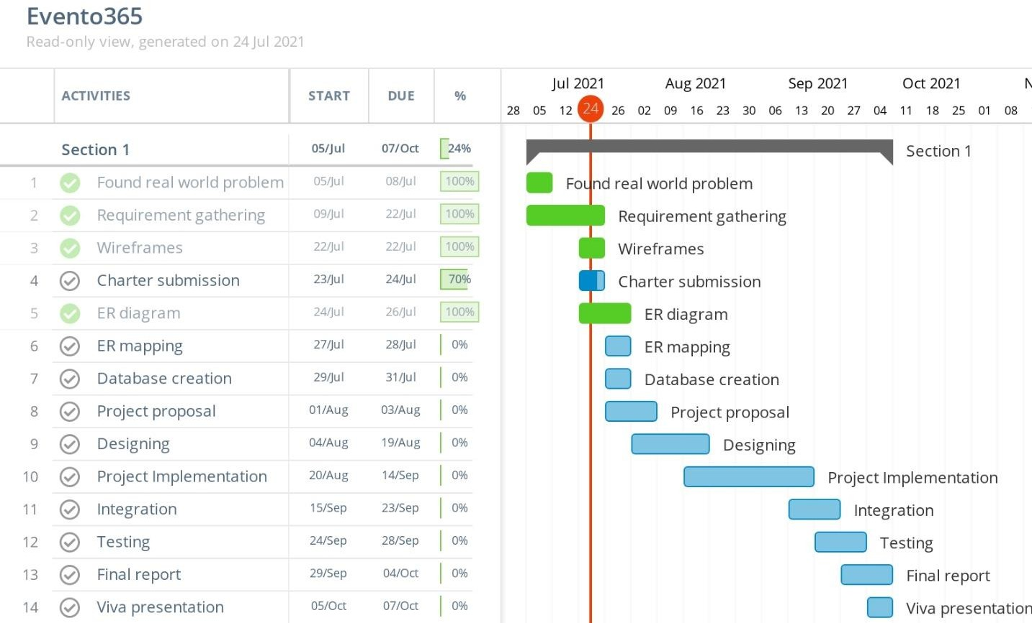

*Figure 2 – Gantt Chart of the purposed system development plan.*

# Task Distribution

# Following table 1 - 4 shows work distribution among team members.

*Table 1 : System functionalities.*

|  |  |
| --- | --- |
| **Name** | **Description** |
| U.M.D.B. Alahakoon (IT20205638) | **User Profile Management**   * Add user profile information (both Customer/Admin). * Update/Remove user profile information. * Display profile information. * Access separation for site admins. * Implementation of login security. * Admin can search user easily using a given keyword. * Generate reports related to the user login and browsing time.   **Booking Management**   * Create bookings. * Update/Remove booking entries. * Display booking information for a given Booking ID. * Generate monthly bookings summary report. * Push notifications.   **Location Management**   * Create, Update and Delete Venues. * Search location from a given keyword. |
| R.M.Isuru Sahan Kumarasingha (IT20133290) |

*Table 2 : System functionalities.*

|  |  |
| --- | --- |
| **Name** | **Description** |
| Y.G.I.S.Wickramanayake (IT20274252) | **Vehicle Renting and Driver Management**   * Add, Remove Vehicles * Update driver details. * Add and Remove drivers. * View available Vehicles. * View available Drivers. * Calculate monthly earnings from vehicle renting service. * Generate report for vehicle hiring summery. * Admin can search existing vehicle details.   **Payment Management**   * Add credit or debit cards details to the system. * Remove credit or debit card from the system. * Update/change payment details. * User can apply promo codes to get discounts. * Admin can search payment details by customer name. * View pending payments. * Generate monthly payment reports. * Generate payment Invoices. |
| D.M.C.L.B. Dissanayake (IT20224370) |

*Table 3 : System functionalities.*

|  |  |
| --- | --- |
| **Name** | **Description** |
| V.D.M.H.D. Rathnayake (IT20198336) | **Evento 365 Store Management**   * Add products * Update and delete product details * Assign products to a category * Search products * Add items to shopping cart * Edit and delete items in the shopping cart * Generate monthly report on all the orders * Update the current store and generate a list of products that needs to be restocked   **Item Renting Service**   * Add, remove, update items. * Manage categories. * Display description about items. * Search items using a given keyword. * Generate summary reports on rented items such as mostly rented item of the month. |
| S.M.T.N Samarakoon (IT20245092) |

*Table 4 : System functionalities.*

|  |  |
| --- | --- |
| **Name** | **Description** |
| K.M.M.Y.S. Ranathunga (IT20274320) | **Event planning agent management**   * User can insert details and book event planner. * Insert event planning agent details. * Edit and delete event planning agent details. * Generate the agent daily report. * Search and choose event planners. * View available agents. * User can give feedback to agent. * User can edit their feedback.   **Catering Service Management.**   * Adding, updating and removing food items from the database. * Generate the monthly report * Search and select the food category * System displays total price related to the selected food items. * User can add anything they want to order. * User can modify ordered food items. |
| S.M.K.P.K. Sakalasooriya (IT20231682) |

# References

1. I. B. (. LTD, ". i. (2019). *[Online]. Available:* [*http://www.intoweb.com/index.php.*](http://www.intoweb.com/index.php) *[Accessed 02 04 2019].* London: ABC .
2. Maidenhead, M. H. (1999). *Turner, JR (1999) The Handbook of Project-Based Management.*